EXPT NO:5 | DASHBOARD DESIGNING
DATE: 24.01.2026 | DASHBOARD DESIGNING

PRE-LAB QUESTIONS

- How do dashboards support strategic decision-making?
Dashboards consolidate large volumes of data into visual summaries that help decision-makers understand overall performance quickly. They highlight trends, patterns, and problem areas that may not be obvious in raw data. This enables informed, timely, and data-driven strategic decisions.

- What role do dashboards play in AI monitoring systems?
Dashboards act as the interface between AI systems and users by visualizing AI-generated insights and predictions. They help monitor system behavior, detect anomalies, and track performance metrics in real time. This ensures transparency and effective supervision of AI-based processes.

- Why is interactivity essential in modern dashboards?
Interactivity allows users to filter, drill down, and explore data based on their specific needs. It enables deeper analysis without creating multiple static reports. This flexibility improves understanding and supports personalized decision-making.

- What cognitive overload issues exist in dashboards?
Cognitive overload occurs when dashboards present too many visuals, colors, or metrics at once. This can overwhelm users and reduce their ability to focus on key insights. Effective dashboard design minimizes clutter and emphasizes the most important information.

- How are KPIs derived from raw data?
KPIs are derived by processing raw data through aggregation, calculation, and transformation. Measures such as averages, totals, and percentages are used to summarize performance. These KPIs are aligned with organizational goals to track effectiveness and outcomes.

OBJECTIVE: To design an interactive analytical dashboard for monitoring key metrics.
SCENARIO: An AI-based smart campus system requires a dashboard to monitor attendance, academic performance, and resource utilization in real time.
IN-LAB TASKS (Using PowerBI)
• Design KPI cards for attendance and performance
• Implement filters by department and semester
• Link multiple views for drill-down analysis

DASHBOARD
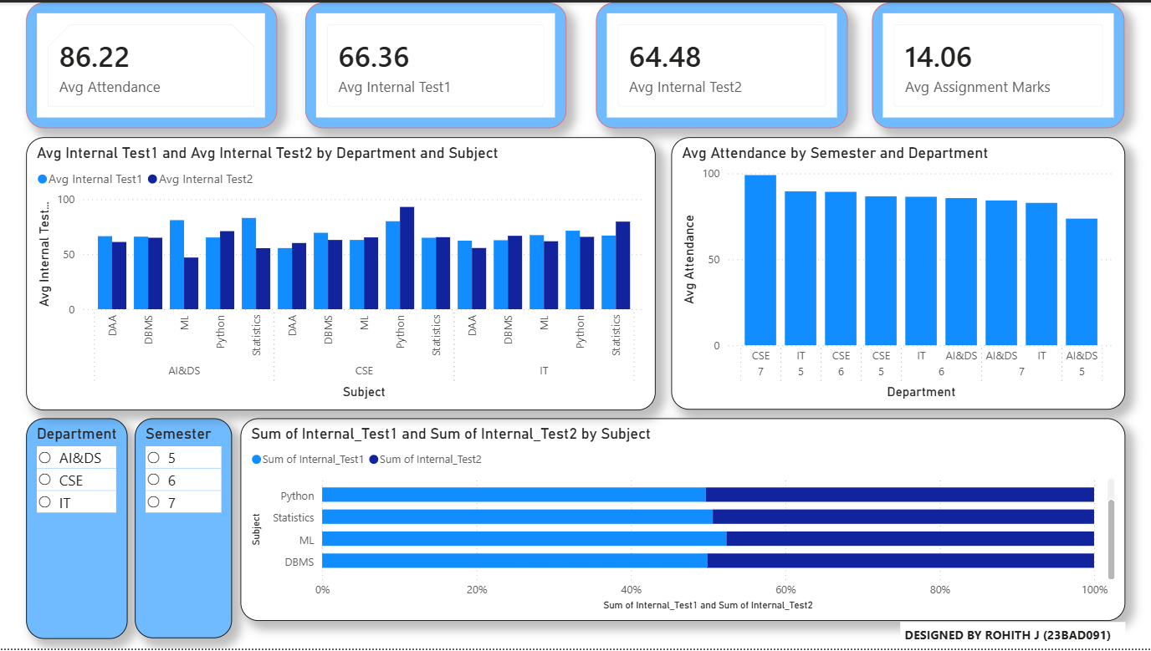
VAIRAVANATHAN S (23BAD311)

POST-LAB QUESTIONS

- How does interactivity improve analytical depth?
Interactivity in the dashboard allows users to filter data by department and semester for focused analysis. Drill-down functionality enables exploration from department-level summaries to subject-level performance. This layered analysis provides deeper insights into academic patterns.

- Which KPIs are critical for academic monitoring?
Average attendance percentage is critical for measuring student engagement. Internal test and assignment averages indicate academic performance and learning progress. Together, these KPIs provide a comprehensive view of student and departmental performance.

- What design principles prevent information overload?
Clear layout structure, limited KPI cards, and consistent color usage help reduce visual clutter. Grouping related metrics and using drill-down instead of multiple charts improves clarity. These principles ensure users can easily focus on meaningful insights.

- How can dashboards be integrated with AI alerts?
Dashboards can work with AI models to automatically detect unusual trends such as low attendance or declining scores. Visual alerts or highlighted KPIs can notify administrators of potential issues. This enables proactive and timely corrective actions.

- How do dashboards enhance transparency in institutions?
Dashboards provide real-time access to academic and attendance data for stakeholders. This visibility promotes accountability and informed decision-making across departments. Transparent data presentation builds trust and supports continuous improvement.

LEARNING OUTCOME: Students understand dashboard design for AI-driven environments.

ASSESSMENT
Description | Max Marks | Marks Awarded
Pre Lab Exercise | 5
In Lab Exercise | 10
Post Lab Exercise | 5
Viva | 10
Total | 30
Faculty Signature

